Lab Practical #01:

Study of basic networking commands and IP configuration.

# Practical Assignment #01:

1. Perform and explain various networking commands listed below:
   1. ipconfig
   2. ping
   3. getmac
   4. systeminfo
   5. traceroute / tracert
   6. netstat
   7. nslookup
   8. hostname
   9. pathping
   10. arp

## ipconfig

### Description:

The ipconfig command is used in **Windows** to **view and manage the IP address** and **network configuration** of your system. It helps you check your system’s **IP address**, **subnet mask**, **default gateway**, and other important network details.

It is very useful for **troubleshooting internet issues** and checking if your computer is properly connected to a network.

|  |  |  |
| --- | --- | --- |
| **No.** | **Option** | **Description** |
| 1. | ipconfig | Shows **basic network info**, like IP address, subnet mask, and gateway. |
| 2. | ipconfig /all | Shows **detailed network info**, including MAC address, DHCP status, etc. |
| 3. | ipconfig /release | **Releases the current IP address** (disconnects from the network). |
| 4. | ipconfig /renew | **Renews the IP address** from the DHCP server (reconnects to the network). |
| 5. | ipconfig /flushdns | Clears the **DNS cache**, helpful for fixing DNS-related issues. |

### Implementation:

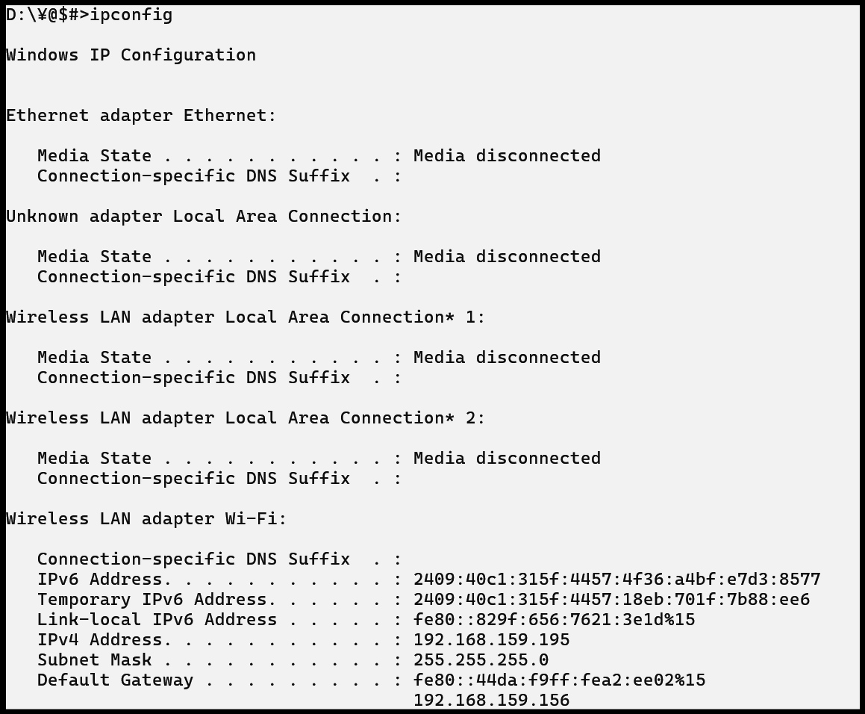

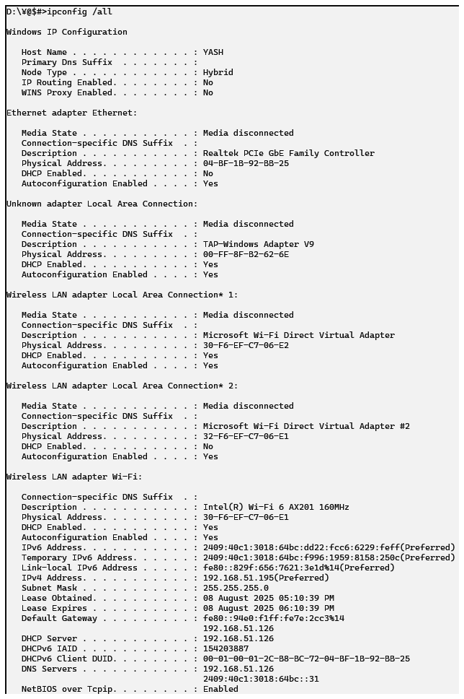

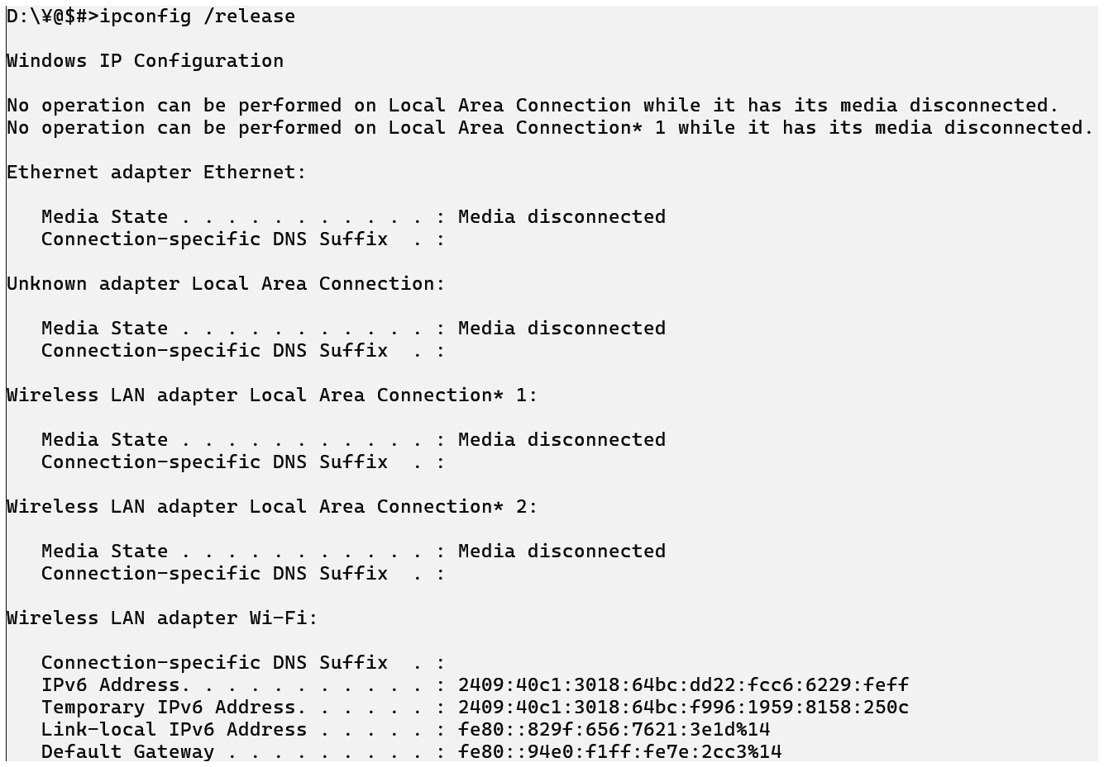

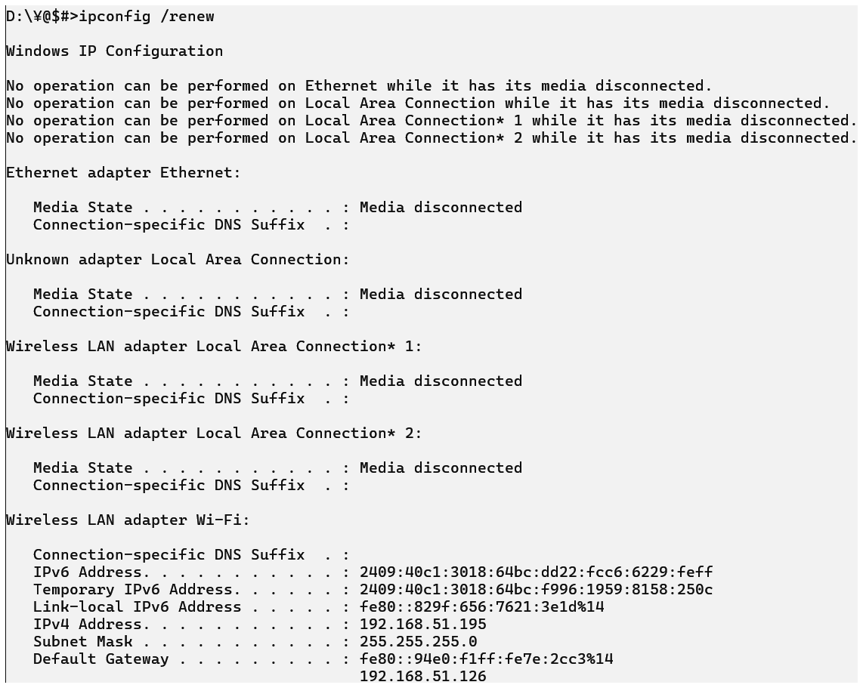



## ping

### Description:

The ping command is used to **check the connection between your computer and another device** (like a website or another computer). It helps you **test if a device is reachable** and how long it takes for data to travel (latency).

It works by sending small packets of data and waits for a reply - if it gets a reply, it means the network is working fine.

|  |  |  |
| --- | --- | --- |
| No. | Option | Description |
| 1 | ping -t | |  | | --- | | **Ping continuously** until manually stopped (use Ctrl + C to stop). | |
| 2 | ping -a | |  | | --- | | **Resolves hostname** from an IP address (reverse DNS lookup). | |
| 3 | ping –n <count> | Sends a specific **number of ping requests**. |
| 4 | ping –l <size> | Sets the **packet size** (in bytes) for the ping request. |

### Implementation:

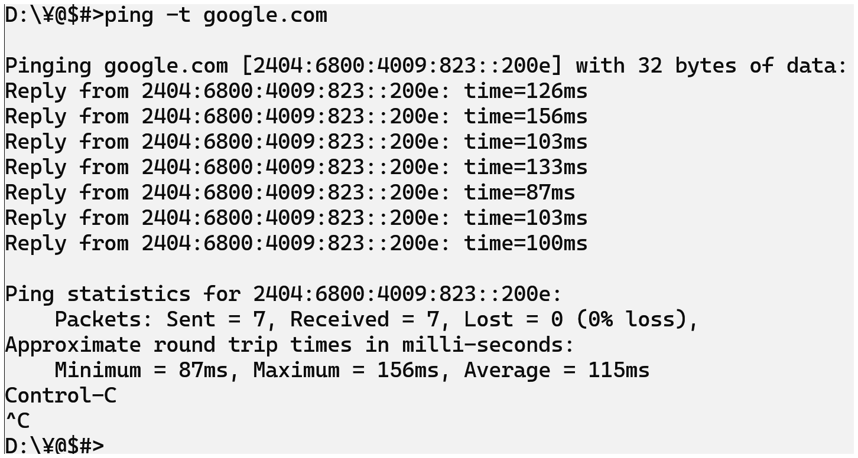

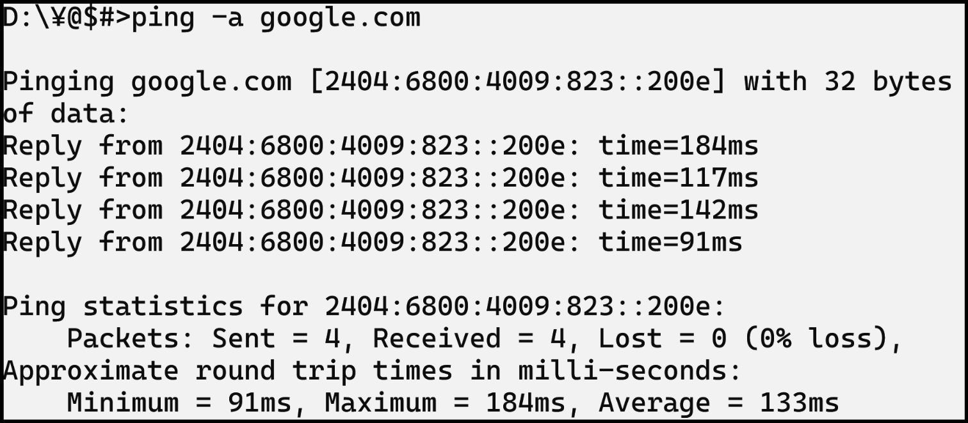

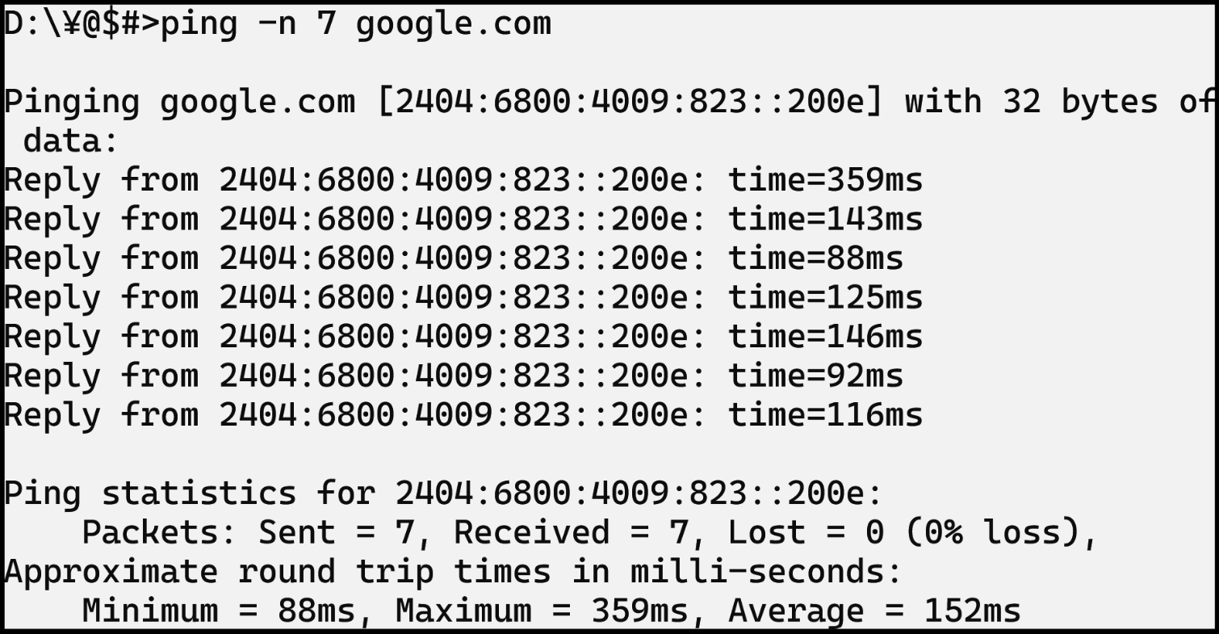

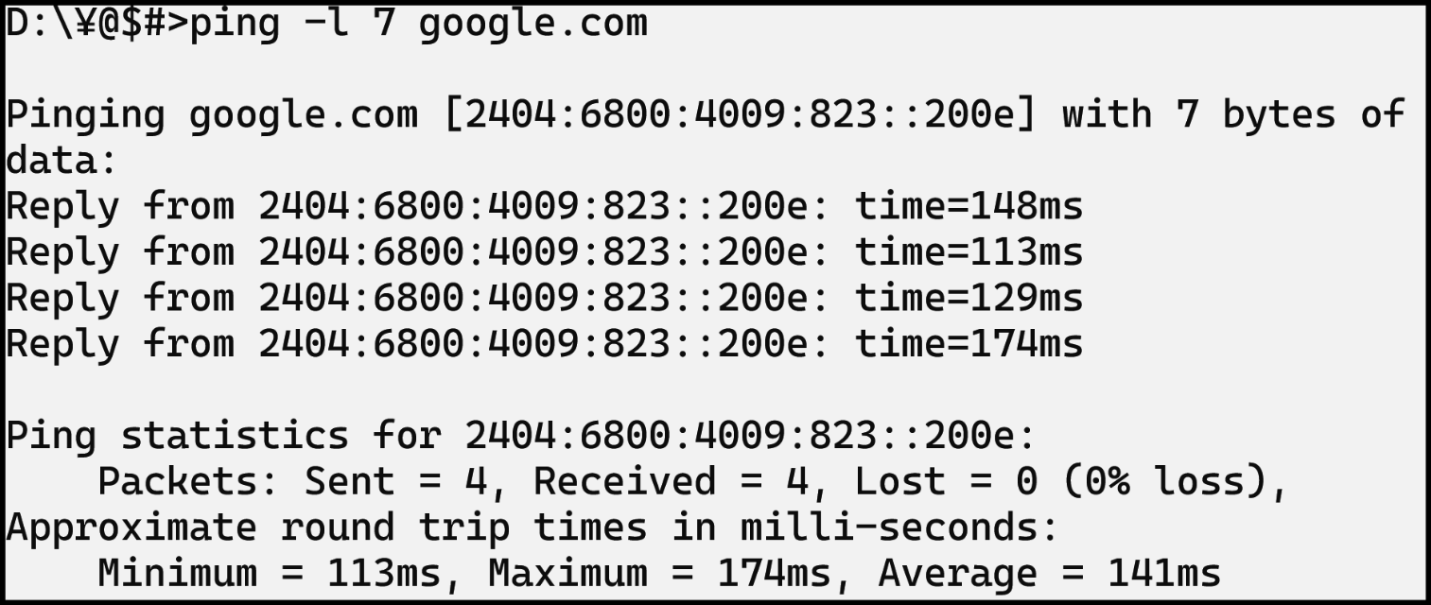

## getmac

### Description:

The getmac command is used to **find the MAC address** (Media Access Control address) of your computer. A **MAC address** is a unique hardware ID assigned to your network adapter.

This command helps in **identifying devices** on a network and is often used in **network security and troubleshooting**.

|  |  |  |
| --- | --- | --- |
| No. | Option | Description |
| 1 | getmac | Displays the **MAC address** of all network interfaces. |
| 2 | getmac /FO csv | |  | | --- | | Outputs the result in **CSV (comma-separated)** format. | |
| 3 | getmac /FO table | Outputs the result in a **formatted table**. This is the default display. |
| 4 | getmac /nh | |  | | --- | |  |  |  | | --- | | **No Header** – Removes the column headers from the output (used with /FO). | |

### Implementation:

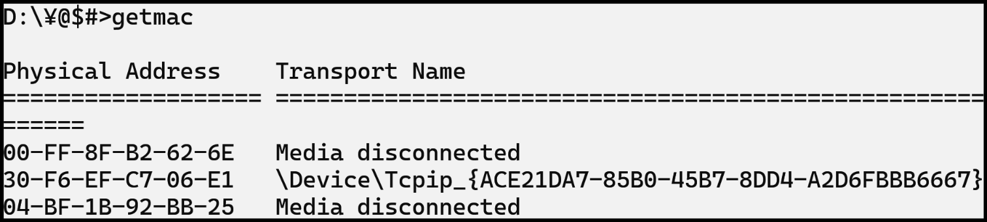

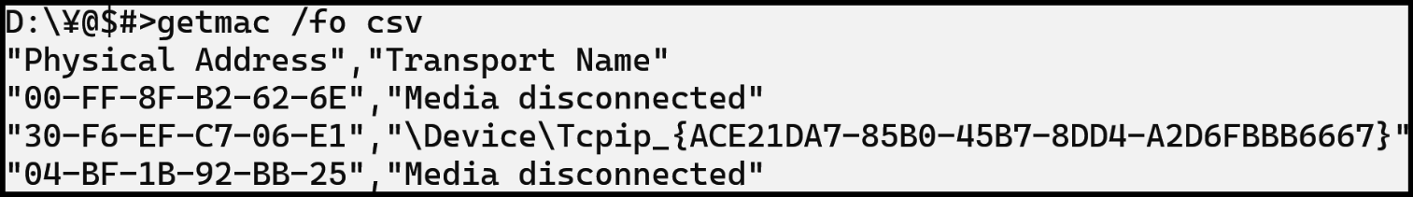

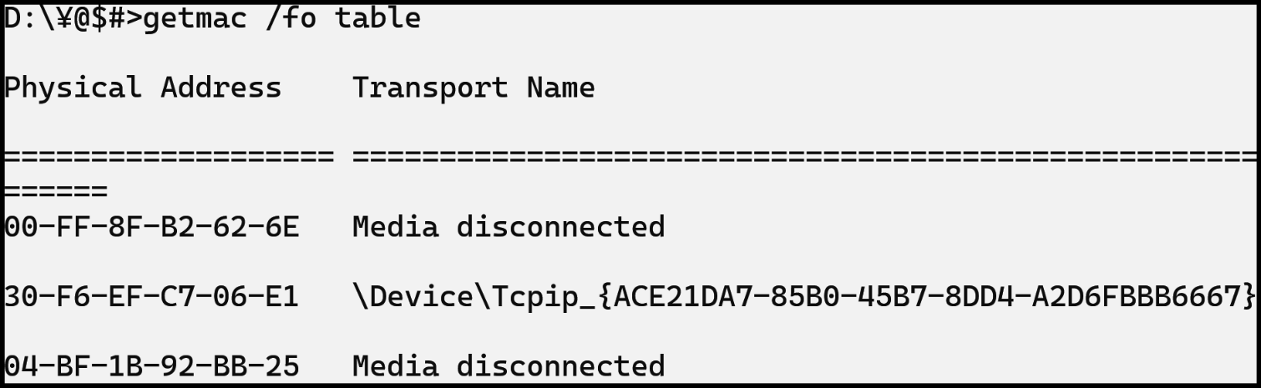

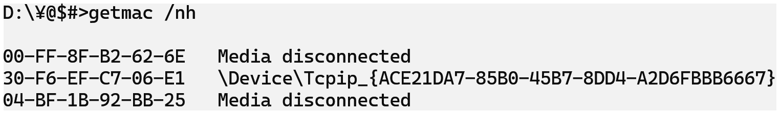

## systeminfo

### Description:

The systeminfo command displays **detailed information about your computer system**. It includes details like **OS version, processor, RAM, system type, BIOS version**, and more.

It is helpful for **checking system specifications**, **troubleshooting issues**, or **creating system reports**.

|  |  |  |
| --- | --- | --- |
| No. | Option | Description |
| 1 | systeminfo | Displays detailed **system configuration** info like OS, RAM, processor, etc. |
| 2 | systeminfo /fo csv | Outputs results in **CSV (Comma-Separated Values)** format. |
| 3 | systeminfo /fo table | Displays output in a **formatted table**. This is the **default format**. |
| 4 | systeminfo /s user | Tries to fetch info from a **remote machine named "user"**. |

### Implementation:

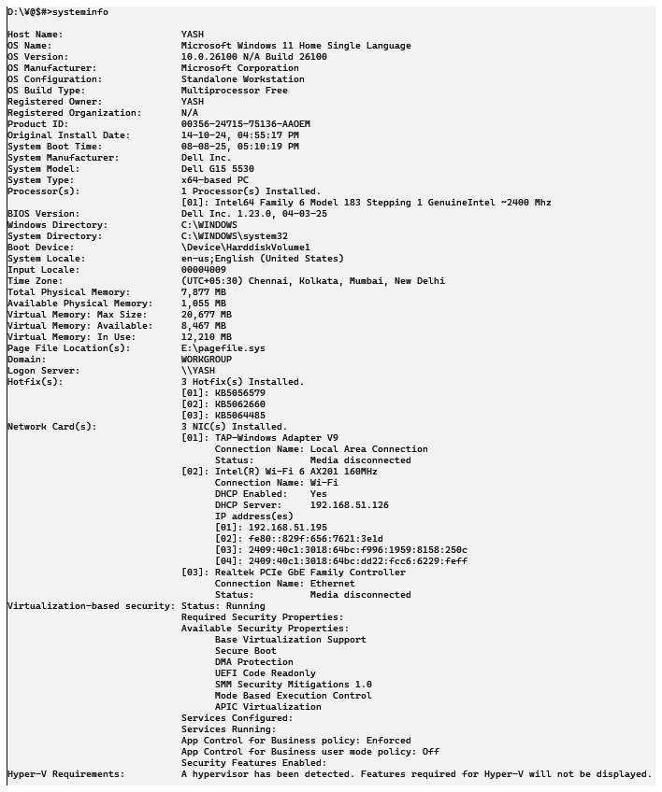

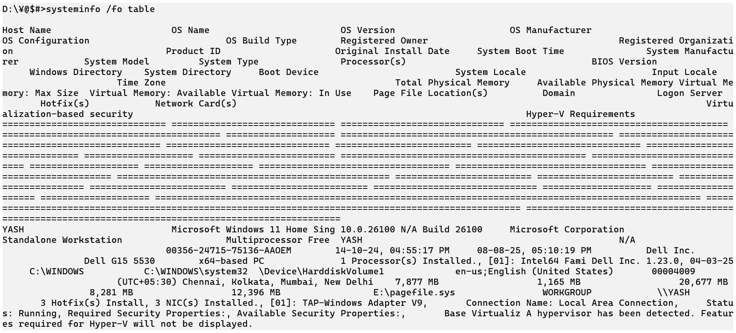

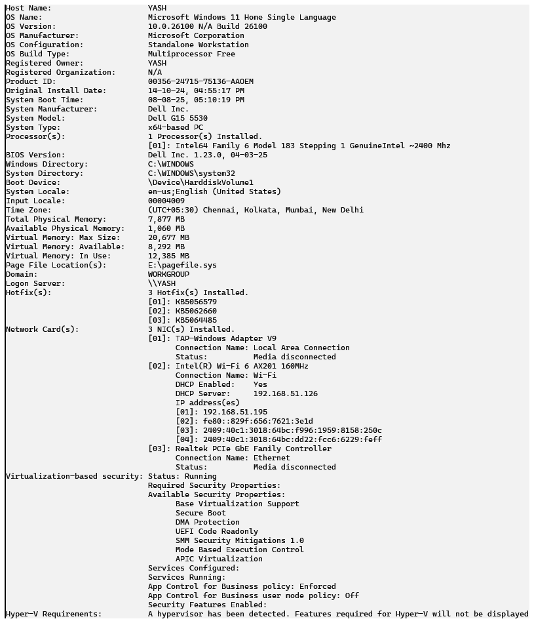

## traceroute / tracert

### Description:

In **Windows**, the command is tracert,  
In **Linux/macOS**, it’s called traceroute  
Both work similarly.

**Description:**

The tracert command shows the **path that data takes from your computer to a destination (like a website)**. It helps you **see all the routers** (called “hops”) the data passes through on the internet.

Very useful for **troubleshooting network issues** and checking **where delays or failures occur** in the network.

|  |  |  |
| --- | --- | --- |
| No. | Option | Description |
| 1 | tracert -d | Prevents tracert from resolving IP addresses to **hostnames**. Speeds up output. |
| 2 | tracert /h | Specifies the **maximum number of hops** to search for the target (default is 30). |
| 3 | tracert /w | Specifies the **wait time (in milliseconds)** for each reply (default is 4000 ms). |
| 4 | tracert /6 | Forces tracert to use **IPv6** instead of IPv4. |

### Implementation:

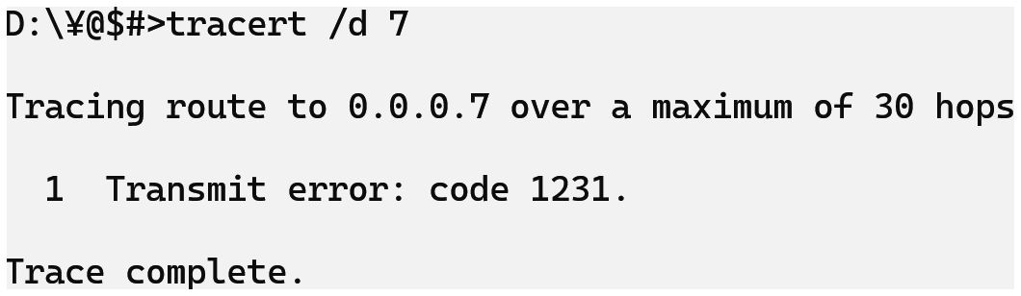

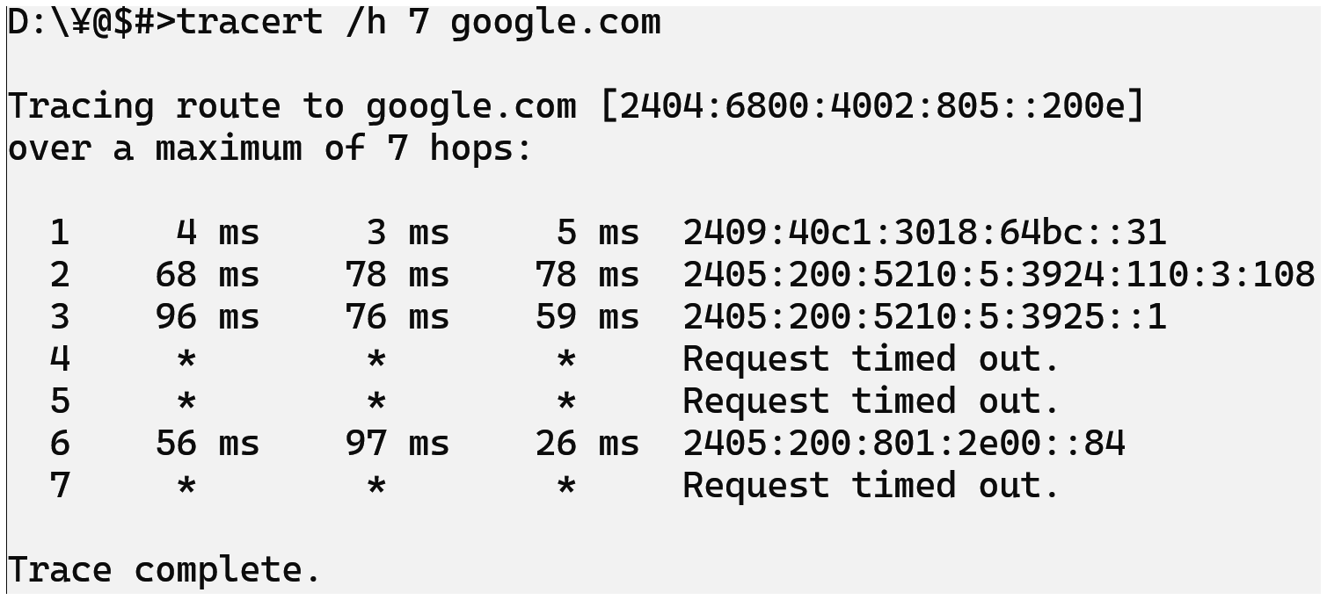

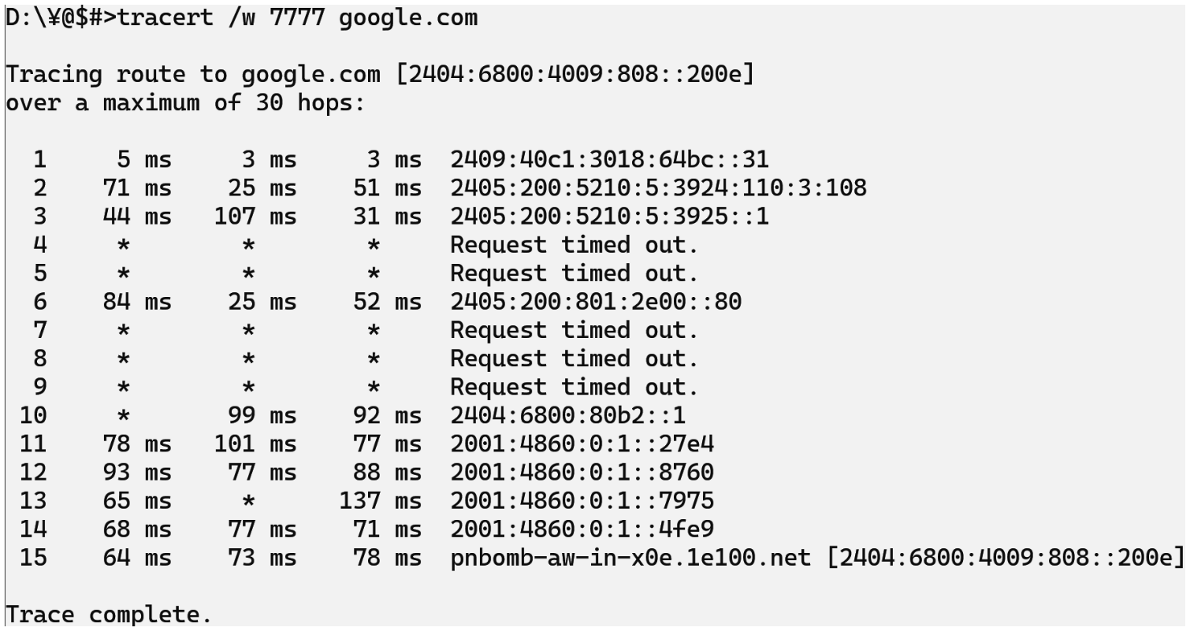

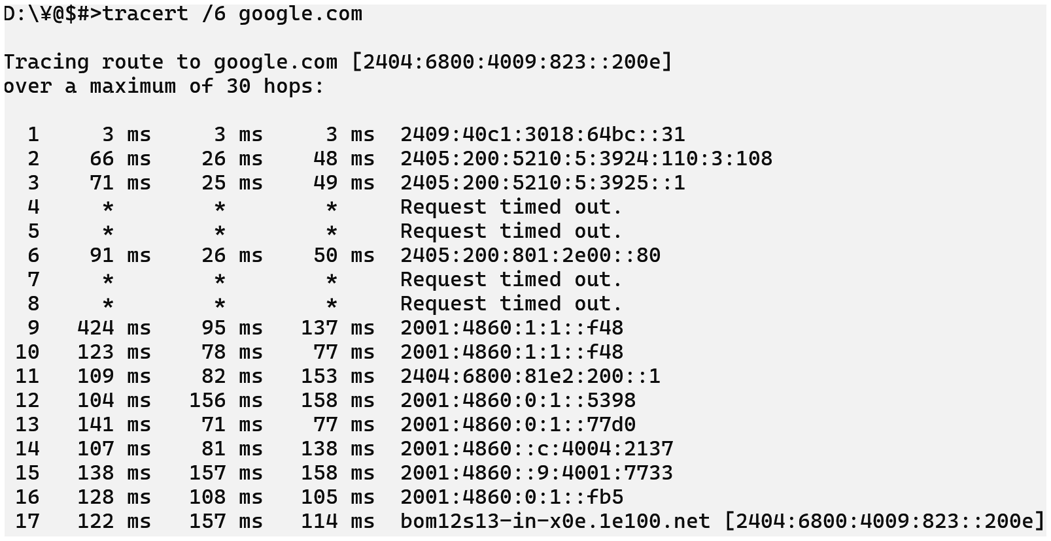

## netstat

### Description:

The netstat command shows **network statistics** and details about **current network connections**, **ports in use**, **protocols**, and more. It's very helpful for **monitoring network activity** and **troubleshooting network or port issues**.

You can use it to find out which **programs are using the internet** or **which ports are open** on your system.

|  |  |  |
| --- | --- | --- |
| No. | Option | Description |
| 1 | netstat -n | |  | | --- | | Displays addresses and ports in **numeric format**, skipping DNS resolution. | |
| 2 | netstat –o | Shows the **Process ID (PID)** for each connection. Useful for identifying apps. |
| 3 | netstat -e | Shows **Ethernet statistics** (bytes sent/received, errors, etc.). |
| 4 | netstat -r | Displays the **routing table** (same as route print). |

### Implementation:

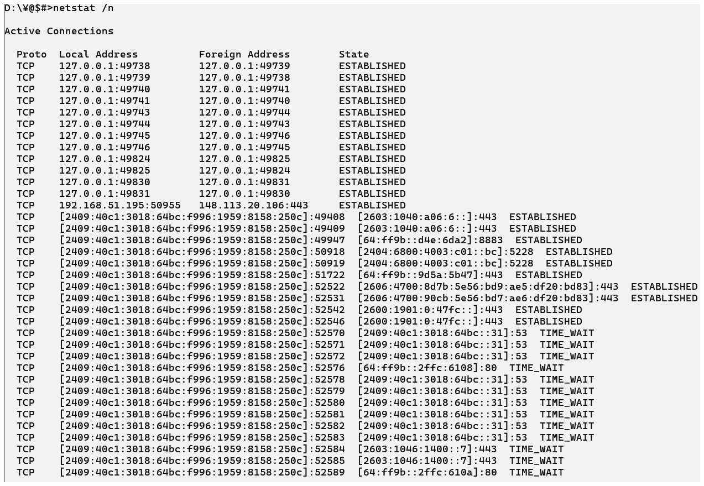

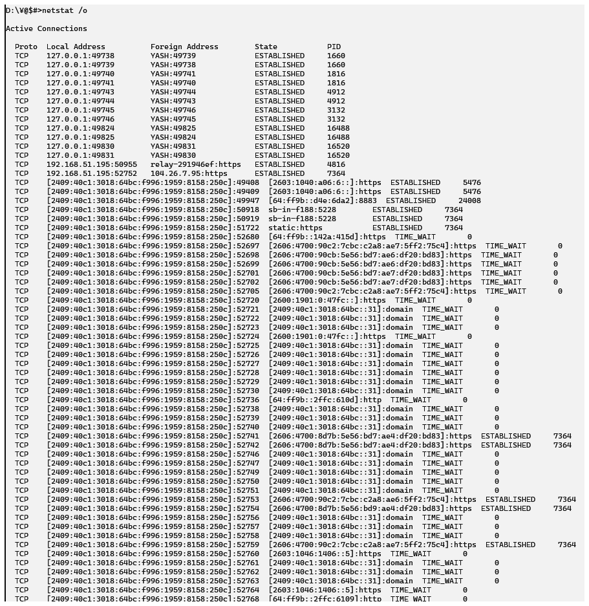

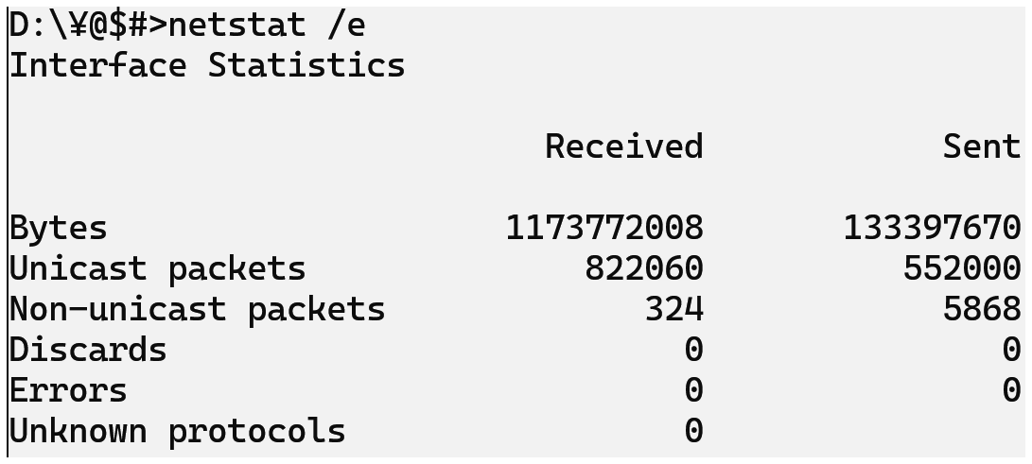

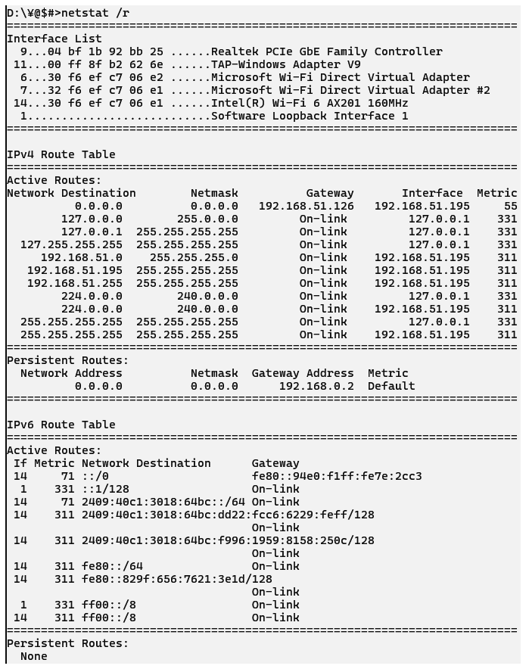

## nslookup

### Description:

The nslookup (Name Server Lookup) command is used to **get the IP address of a domain name** or **find the domain name of an IP address**. It helps in **troubleshooting DNS (Domain Name System) issues**.

It's commonly used to check if a domain is properly resolving to the correct IP address.

|  |  |  |
| --- | --- | --- |
| No. | Option | Description |
| 1 | nslookup | Enters **interactive mode** where you can run multiple DNS queries |
| 2 | nslookup [domain] | Returns the **IP address** of the given domain (e.g., nslookup google.com) |
| 3 | nslookup [IP] | Returns the **domain name** of the given IP (reverse lookup). |
| 4 | nslookup -debug | Displays **detailed debug** info for the DNS query. |

### Implementation:

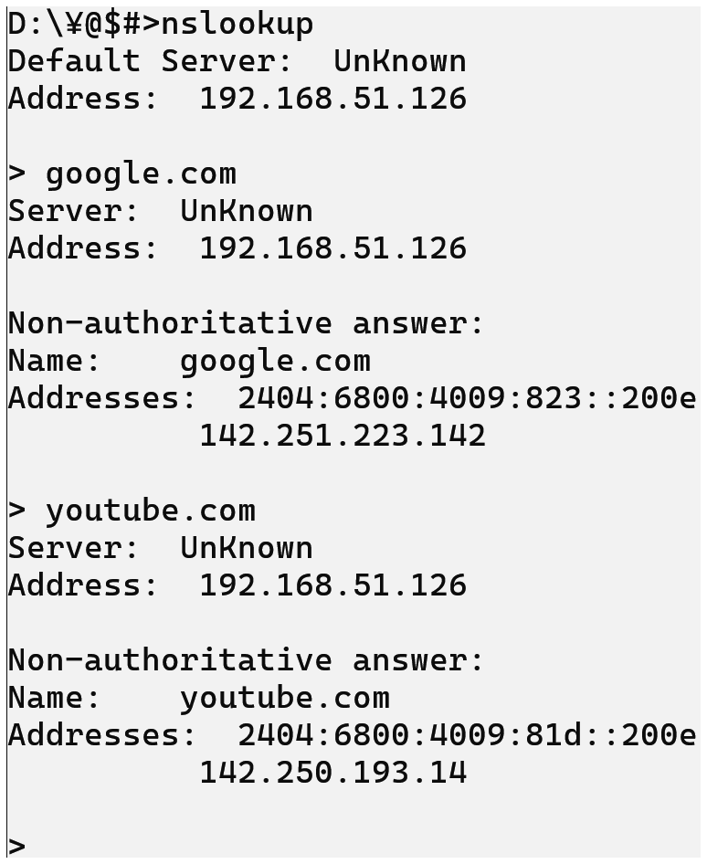

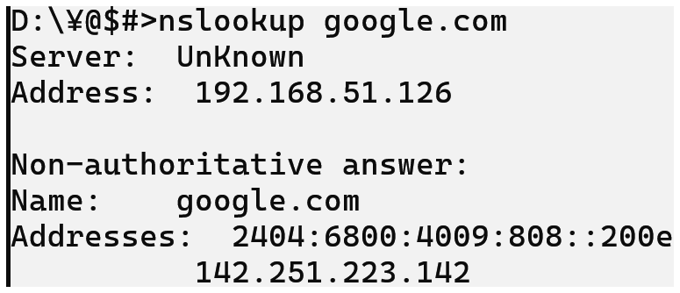

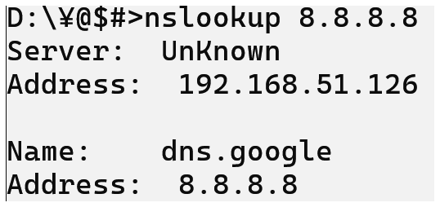

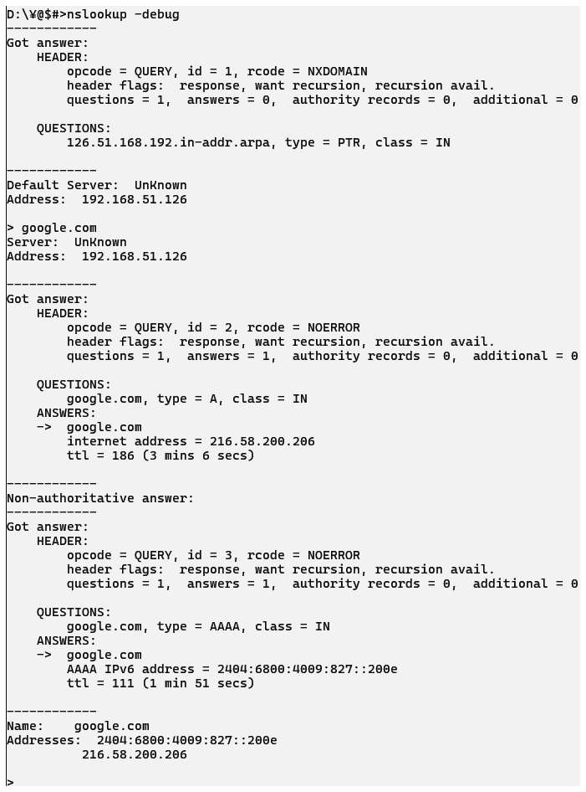

## hostname

### Description:

The hostname command is used to **display the name of your computer (device name)** on the network. This name is used to **identify your system** on local or organizational networks.

It is very simple and useful for checking or confirming your system's **network identity**.

On **Windows**, hostname is mostly just for viewing.  
On **Linux**, it can also be used to **change** the hostname (with root access).

|  |  |  |
| --- | --- | --- |
| No. | Option | Description |
| 1 | hostname | Displays the **name of the current computer (host)** on the network. |
| 2 | hostname /? | Shows **help and usage options** for the command. |

### Implementation:



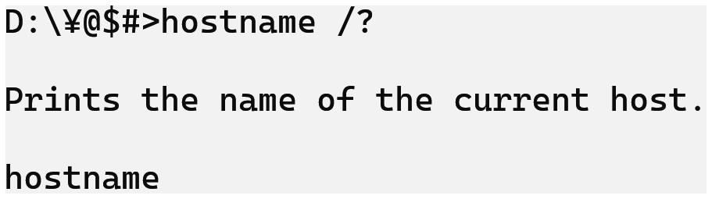

## pathping

### Description:

The pathping command is a combination of **ping and tracert**. It not only shows the **route data takes** to reach a destination but also gives **detailed statistics about packet loss** at each hop (network device) along the way.

It is especially useful for **troubleshooting unreliable networks** or **identifying where packet loss is happening**.

Takes longer to complete than tracert, but provides **more detailed results**.

|  |  |  |
| --- | --- | --- |
| No. | Option | Description |
| 1 | pathping | Traces and analyzes route to google.com |
| 2 | pathping -h <max_hops> | Limits the number of **maximum hops** (default is 30) |
| 3 | pathping -w <timeout> | |  | | --- | | Sets **wait time** (ms) per reply (default is 3000ms) | |
| 4 | pathping -q <queries> | Sets number of **queries (pings)** per hop (default is 100) |

### Implementation:

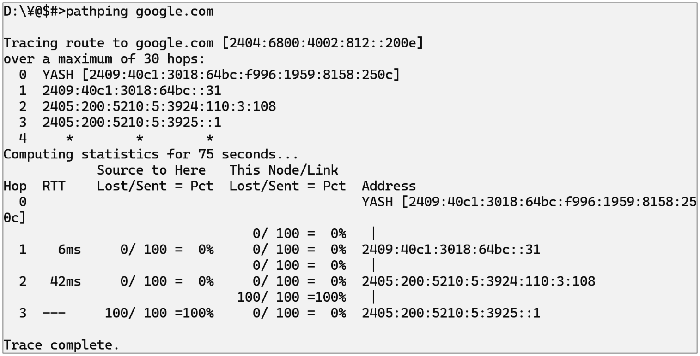

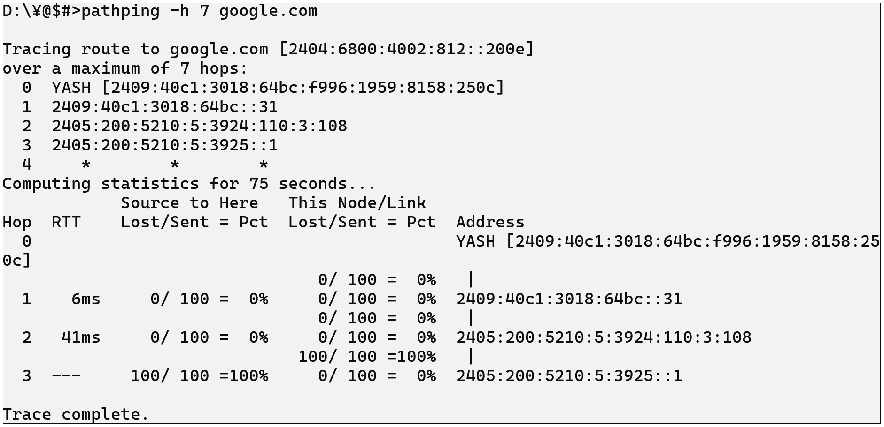

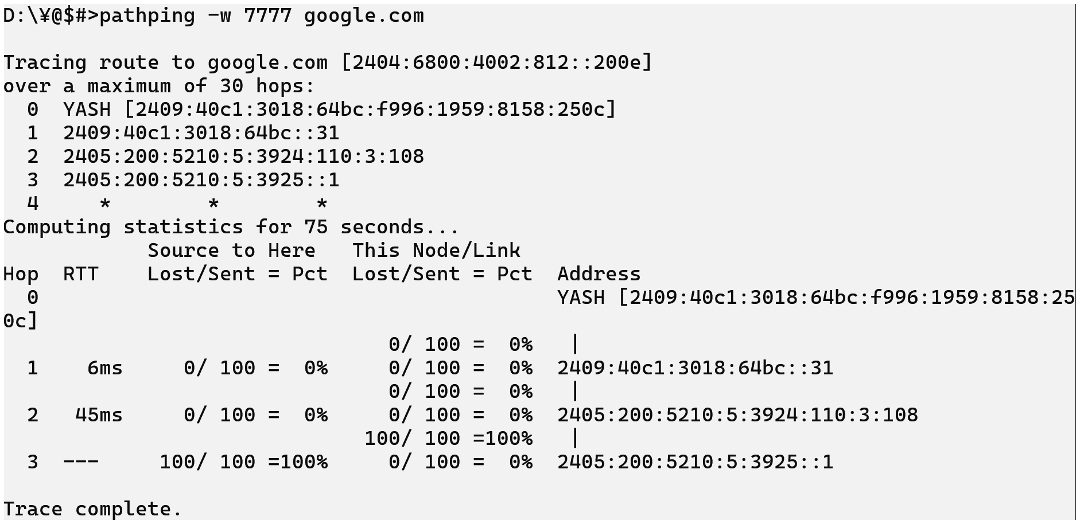

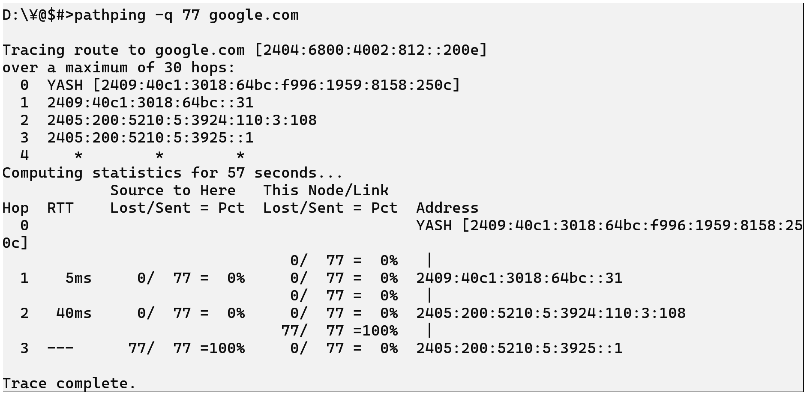

## arp

### Description:

The arp (Address Resolution Protocol) command is used to **view and manage the ARP cache** on your system. ARP is the protocol that maps **IP addresses to MAC addresses**. When your computer communicates over a network, it needs to know the **MAC address** of other devices — and ARP helps with that.

This command is useful for **network diagnostics**, especially in **local networks (LANs)**.

Mostly used by network administrators to **inspect or control device communication** on a LAN.

|  |  |  |
| --- | --- | --- |
| No. | Option | Description |
| 1 | arp -a | Displays the **current** ARP table (IP–MAC mappings). |
| 2 | arp -g | Same as arp -a (just **another way** to show the table). |
| 3 | arp -d <IP> | **Deletes** a specific ARP entry. Requires admin rights. |
| 4 | arp -s <IP> <MAC> | **Adds a static entry** (manual IP-to-MAC mapping). |

### Implementation:

